

ALPHA-PIR

**AIR DUCT SYSTEM**

Premium quality and performance pre-insulated Polyisocyanurate air duct system.

**PRODUCT CATALOGUE**

6th Issue - October 2023

**MEP for a Better Living**

# COMPANY PROFILE

**DCL Certification for PIR panels**

**New Facility in Jabal Ali / Installation of new Phenolic (PF) line**

The panel manufacturing facility was shifted to Jabal Ali Industrial to upgrade the size, introduce new sections and production lines and increase the overall production capacity to cover the increased demand from the local, regional and international markets in addition to introducing new products to cover new market segments. The current annual production capacity is 5 million square meters.

**ISO 9001 Certification**

**ISO 14001 and OHSAS 18001 Certification**

**Certifire Certification for PIR and PF panels UL listing for PF duct system**

ALPHA DUCTS LLC is one of the highly advanced and modernized manufacturers of insulation foam panels, pre-insulated air duct systems and accessories based in Dubai, United Arab Emirates and having an extensive international network to serve customers worldwide.

2004

2005

2006

2008

2009

2012

2013

2016

2018

**Established**

ALPHA DUCTS LLC was established in 2004 as a local manufacturing facility in Al Quoz, Dubai, UAE to meet the requirements of the local market.

**Upgrade of existing Polyisocyanurate (PIR) line**

It was upgraded in 2005 to a huge capacity manufacturing facility with fully automated machineries and qualified technicians for a worldwide supply.

ALPHA DUCTS LLC is manufacturing insulation panels and pre-insulated air duct systems in the brand name **ALPHA** which are prime quality insulation panels and air ducts meeting the international quality, health, safety, environment and fire standards.

**DCL Certification for PF panels**

**Joined FJ Group**

ALPHA DUCTS LLC is certified to the highest international standards of quality, occupational health, safety and environment: ISO 9001, ISO 14001 and ISO 45001.

ALPHA DUCTS LLC products are certified to the highest international air leakage, fire and safety standards: UL listing from Underwriters Laboratories, Certifire certification from Warringtonfire, DCL certification from Dubai Municipality and air leakage certification from BSRIA in addition to complying with BS and EN standards..

**ALPHA-PIR** air duct system is a lightweight premium quality and performance pre-insulated Polyisocyanurate air duct system for air distribution.

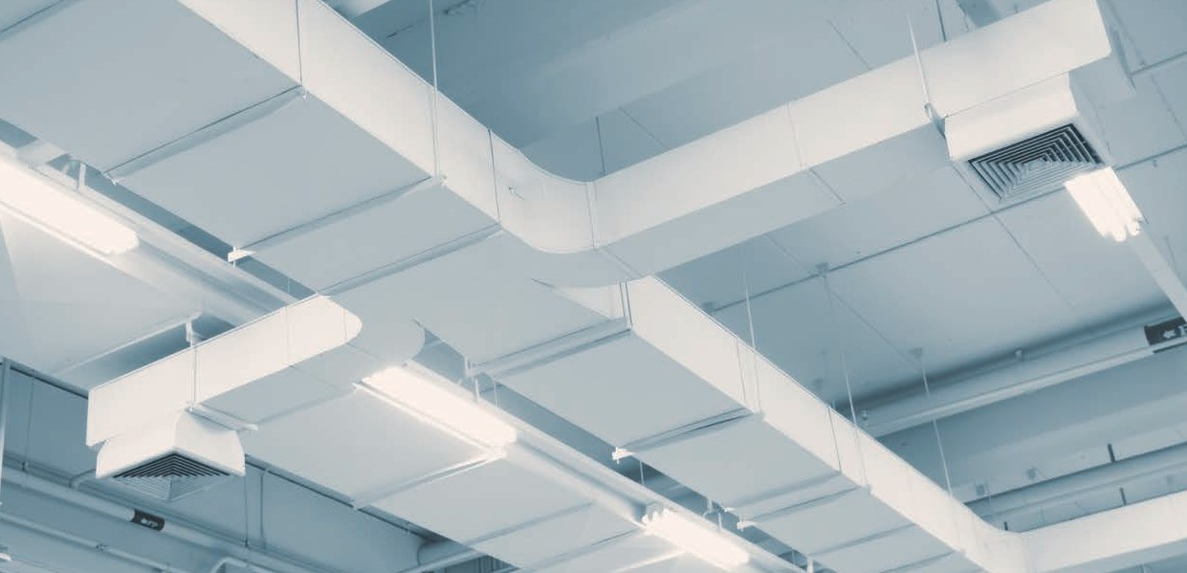

**INTRODUCTION**

**ALPHA-PIR** air duct system consists of **ALPHA-PIR** Polyisocyanurate panels, specified joining systems and range of accessories in addition to the recommended fabrication and installation procedures.

The ducts are fabricated in sections up to 4 m length and offer multiple advantages in reducing cost and energy usage when compared to the conventional sheet metal duct systems.

**ALPHA-PIR** air duct system is compatible with the standard sheet metal control dampers, fire dampers, access doors and supporting systems used in the conventional sheet metal duct systems.

## RANGE AND LIMITATIONS

**ALPHA-PIR** air duct system is recommended to be used in the systems of supply, return, fresh air and exhaust for air conditioning, heating and ventilation within the below limits:



**MAXIMUM PRESSURE:**

2000 Pa positive and 750 Pa negative

**SIZE:**

Please refer to the fabrication and installation procedures. Any size can be fabricated after the technical consultation of ALPHA DUCTS LLC technical team.

**MAXIMUM AIR VELOCITY:**

25 m/s

**TEMPERATURE:**

Air temperature between -20°C and +110°C

**ALPHA-PIR** air duct system is recommended to be used in various types of projects: residential, commercial, mixed use, hotels and light industrial.

**ALPHA-PIR** air duct system is highly recommended to be used in high specifications projects like hospitals, food and beverage industry, pharmaceutical industry, air and hygiene controlled environments and many more where the usage of fiber insulation is not allowed.

**ALPHA-PIR** air duct system is recommended to be used for internal and external applications and can be installed in visible open areas, above false ceilings and within confined enclosures.

**ALPHA-PIR** air duct system should not be used in the following applications:

* Chemical, fumes and smoke exhaust systems.
* Kitchen and grease exhaust systems.
* Air systems carrying any type of solid particles.
* Fire resistant duct systems.
* Hot air systems where the air temperature exceeds +110°C.
* Air systems that do not have automatic temperature control as per the indicated range.

**DESIGN AND PRESSURE DROP**

**ALPHA-PIR** air duct system follows the same calculation and duct sizing methods used for the rectangular duct designing in the conventional sheet metal duct systems.

The pressure drop in **ALPHA-PIR** air duct system can be compared to the one in the conventional sheet metal duct systems. Therefore the pressure drop data from the sheet metal duct systems can be used for calculating the pressure drop in **ALPHA-PIR** air duct system.

**ALPHA-PIR** air duct system fabricated in line with the recommended fabrication procedure using the specified types of transverse joints and the specified accessories comply with the air leakage requirements as per HVCA DW144 standard.

**AIR LEAKAGE**

|  |  |  |  |
| --- | --- | --- | --- |
| **STANDARD** | **JOINT** | | |
| **HVCA DW144** | Male / Female | Polymer invisible flange | Aluminium invisible flange |
| Class C | Class C | Class C |

## ADVANTAGES AND BENEFITS



**Light weight:** The ducts fabricated from **ALPHA-PIR** panels have a considerably lower weight when compared to the conventional sheet metal ducts.

**Installation speed:** Because of the light weight, the ducts fabricated from **ALPHA-PIR** panels can be installed faster than the conventional sheet metal ducts and therefore offer a huge saving in installation time and manpower cost.

**Environment friendly: ALPHA-PIR** panels are CFC and HCFC free.

**Moisture resistance:** The usage of the aluminium foil facing makes **ALPHA-PIR** panels highly resistant to moisture and eliminates the need of a vapor barrier used with the traditional fiber insulation.

**Health and safety: ALPHA-PIR** panels are resistant to bacteria and microbes, fungal and mould growth, will not sustain vermin, are odorless and have a fiber free foam core.

**Visible application: ALPHA-PIR** air duct system is aesthetically pleasing in open to view applications.

**External application: ALPHA-PIR** air duct system can be used in external applications.

**Air leakage:** The recommended fabrication procedure allowing the combination of the suitable number of pieces in addition to the possibility of fabricating duct pieces in sections up to 4 m length will reduce the total number of joints in **ALPHA-PIR** air duct system compared to the conventional sheet metal duct systems. This will result in reducing the volume of air leakage in the full system.

|  |  |  |  |  |  |
| --- | --- | --- | --- | --- | --- |
| **MECHANICAL PROPERTIES** | | | | |  |
|  |  | Thermal conductivity | 0.022 W/m.K | ASTM C518 at 10°C |  |
|  |  | Water vapor transmission | ZERO g/h.m2 | ASTM E96 |  |
|  |  | Temperature range | -20°C and +110°C | As per standard practice |  |
|  |  | Minimum compressive strength | 200 kPa | ASTM D1621 at 10% deformation |  |
|  |  | Minimum flexural strength | 1200 kPa | ASTM C203 |  |
|  |  | Closed cell content | 90% | BS EN ISO 4590 |  |

# ALPHA-PIR PANELS

**ALPHA-PIR** panels consist of a formaldehyde free, fiber free, high performance rigid thermoset Polyisocyanurate foam core faced on both sides with an extremely durable, protective, low vapor permeability aluminium foil.

The foam core is produced using a CFC / HCFC free blowing agent having a zero Ozone Depletion Potential (ODP) and a Global Warming Potential (GWP) lower than 5.

The aluminium foil is bonded to the foam core by heat reaction during the manufacturing process without using additional adhesives. The aluminium foil is lacquered with a factory applied corrosion and UV resistant polymer coating.

### ALPHA-PIR PANEL FOR INTERNAL USE

#### AD-PIR-12-10

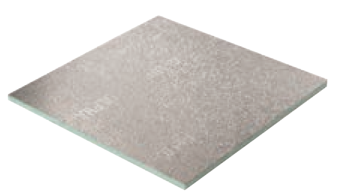

Thickness : 12 mm

Minimum density : 50 kg/m3

Dimensions : 4000 mm x 1200 mm and 3000 mm x 1200 mm Aluminium foil finish : embossed / embossed

Aluminium foil thickness : 80 micron / 80 micron

#### AD-PIR-20-10

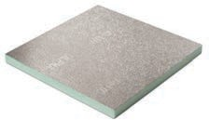

Thickness : 20 mm

Minimum density : 50 kg/m3

Dimensions : 4000 mm x 1200 mm and 3000 mm x 1200 mm Aluminium foil finish : embossed / embossed

Aluminium foil thickness : 80 micron / 80 micron

#### AD-PIR-30-10

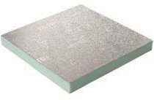

Thickness : 30 mm

Minimum density : 50 kg/m3

Dimensions : 4000 mm x 1200 mm and 3000 mm x 1200 mm Aluminium foil finish : embossed / embossed

Aluminium foil thickness : 80 micron / 80 micron

### ALPHA-PIR PANEL FOR EXTERNAL USE

#### AD-PIR-20-20

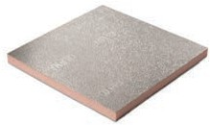

Thickness : 20 mm

Minimum density : 60 kg/m3

Dimensions : 4000 mm x 1200 mm and 3000 mm x 1200 mm Aluminium foil finish : embossed / embossed

Aluminium foil thickness : 80 micron / 200 micron

#### AD-PIR-30-20

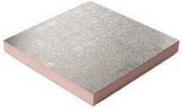

Thickness : 30 mm

Minimum density : 60 kg/m3

Dimensions : 4000 mm x 1200 mm and 3000 mm x 1200 mm Aluminium foil finish : embossed / embossed

Aluminium foil thickness : 80 micron / 200 micron

### ALPHA-PIR PANEL WITH SMOOTH FACER

#### AD-PIR-S-20-10

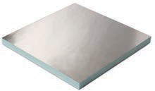

Thickness : 20 mm

Minimum density : 55 kg/m3

Dimensions : 4000 mm x 1200 mm and 3000 mm x 1200 mm Aluminium foil finish : smooth / embossed

Aluminium foil thickness : 80 micron / 80 micron

#### AD-PIR-S-20-20



Thickness : 20 mm

Minimum density : 60 kg/m3

Dimensions : 4000 mm x 1200 mm and 3000 mm x 1200 mm Aluminium foil finish : smooth / embossed

Aluminium foil thickness : 80 micron / 200 micron

#### AD-PIR-S-30-10

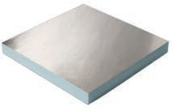

Thickness : 30 mm

Minimum density : 55 kg/m3

Dimensions : 4000 mm x 1200 mm and 3000 mm x 1200 mm Aluminium foil finish : smooth / embossed

Aluminium foil thickness : 80 micron / 80 micron

#### AD-PIR-S-30-20



Thickness : 30 mm

Minimum density : 60 kg/m3

Dimensions : 4000 mm x 1200 mm and 3000 mm x 1200 mm Aluminium foil finish : smooth / embossed

Aluminium foil thickness : 80 micron / 200 micron

# ALPHA-PIR-PLUS PANELS

**ALPHA-PIR-PLUS** panels are developed and used specifically in projects with high end hygiene specifications like hospitals, food and beverage industry and pharmaceutical industry where the surface resistance of the duct system against bacteria and microbes is essential and critical.

**ALPHA-PIR-PLUS** panels consist of a formaldehyde free, fiber free, high performance rigid thermoset Polyisocyanurate foam core faced on both sides with an extremely durable, protective, low vapor permeability aluminium foil.

The foam core is produced using a CFC / HCFC free blowing agent having a zero Ozone Depletion Potential (ODP) and a Global Warming Potential (GWP) lower than 5.

The aluminium foil is bonded to the foam core by heat reaction during the manufacturing process without using additional adhesives.

**ALPHA-PIR-PLUS** panels are manufactured using an aluminium foil facer with a special coating to provide the necessary resistance against bacteria and microbes.

**ALPHA-PIR-PLUS** panels are tested and verified for resistance against bacteria and microbes growth as per the following codes and standards:

* Bacteriological Analytical Manual USFDA January 2001.
* Compendium of Methods for the Microbiological Examination of Foods, APHA, 5th Edition.
* ISO 11731:2017, Second edition 05-2017, Water Quality.
* Manual of Microbiological Methods for the Food and Drink Industry, Campden and Chorleywood Food Research Association.

#### AD-PIR-PLUS-20-10

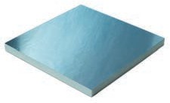

Thickness : 20mm

Minimum density : 55 kg/m3

Dimensions : 4000 mm x 1200 mm and 3000 mm x 1200 mm Aluminium foil finish : smooth / embossed

Aluminium foil thickness : 80 micron / 80 micron

#### AD-PIR-PLUS-20-20



Thickness : 20mm

Minimum density : 60 kg/m3

Dimensions : 4000 mm x 1200 mm and 3000 mm x 1200 mm Aluminium foil finish : smooth / embossed

Aluminium foil thickness : 80 micron / 200 micron

#### AD-PIR-PLUS-30-10

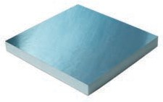

Thickness : 30mm

Minimum density : 55 kg/m3

Dimensions : 4000 mm x 1200 mm and 3000 mm x 1200 mm Aluminium foil finish : smooth / embossed

Aluminium foil thickness : 80 micron / 80 micron

#### AD-PIR-PLUS-30-20



Thickness : 30mm

Minimum density : 60 kg/m3

Dimensions : 4000 mm x 1200 mm and 3000 mm x 1200 mm Aluminium foil finish : smooth / embossed

Aluminium foil thickness : 80 micron / 200 micron

# ACCESSORIES

### ALUMINIUM INVISIBLE FLANGE

#### AD-F-AIF-20

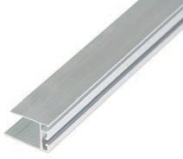

Size : 20 mm

Length : 4 m

#### AD-F-AIF-30

Size : 30 mm

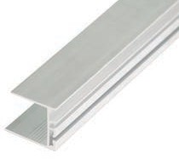

Length : 4 m

### ALUMINIUM INVISIBLE FLANGE-BLUE

For usage with ALPHA-PIR-PLUS duct system

#### AD-F-AIFB-20

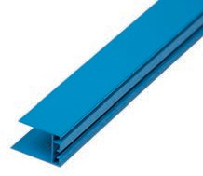

Size : 20 mm

Length : 4 m

#### AD-F-AIFB-30

Size : 30 mm

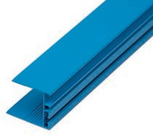

Length : 4 m

### POLYMER INVISIBLE FLANGE

#### AD-F-PIF-20

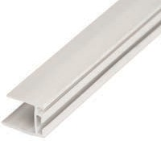

Size : 20 mm

Length : 4 m

### POLYMER H BAYONET

#### AD-F-PHB-20/30

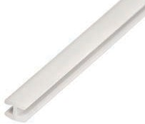

Length : 4 m

### POLYMER INVISIBLE FLANGE-BLUE

For usage with ALPHA-PIR-PLUS duct system

#### AD-F-PIFB-20

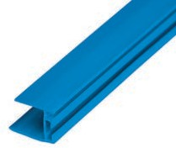

Size : 20 mm

Length : 4 m

### ALUMINIUM CHAIR FLANGE

#### AD-F-ACF-20

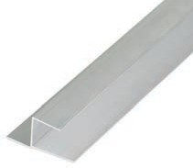

Size : 20 mm

Length : 4 m

#### AD-F-ACF-30

Size : 30 mm

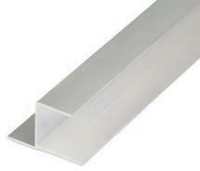

Length : 4 m

### ALUMINIUM CHAIR FLANGE-BLUE

For usage with ALPHA-PIR-PLUS duct system

#### AD-F-ACFB-20

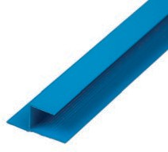

Size : 20 mm

Length : 4 m

#### AD-F-ACFB-30

Size : 30 mm

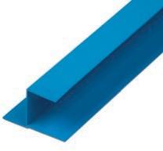

Length : 4 m

### ALUMINIUM U FLANGE

#### AD-F-AUF-20

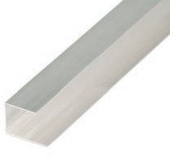

Size : 20 mm

Length : 4 m

#### AD-F-AUF-30

Size : 30 mm

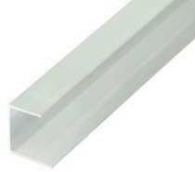

Length : 4 m

### ALUMINIUM U FLANGE-BLUE

For usage with ALPHA-PIR-PLUS duct system

#### AD-F-AUFB-20

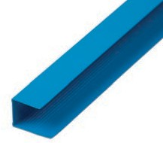

Size : 20 mm

Length : 4 m

#### AD-F-AUFB-30

Size : 30 mm

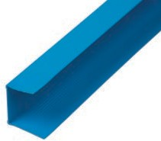

Length : 4 m

### ALUMINIUM F FLANGE

#### AD-F-AFF-20

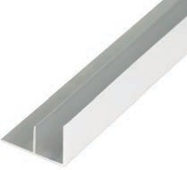

Size : 20 mm

Length : 4 m

#### AD-F-AFF-30

Size : 30 mm

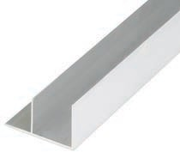

Length : 4 m

### ALUMINIUM F FLANGE-BLUE

For usage with ALPHA-PIR-PLUS duct system

#### AD-F-AFFB-20

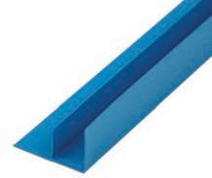

Size : 20 mm

Length : 4 m

#### AD-F-AFFB-30

Size : 30 mm

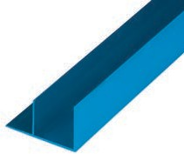

Length : 4 m

### POLYMER COVERING ANGLE

#### AD-F-PCA-20

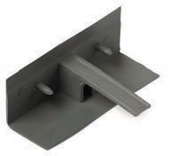

Width / Height: 30 mm Length : 78 mm

#### AD-F-PCA-30

Width / Height: 40 mm Length : 78 mm

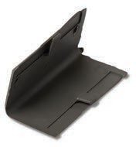

### POLYMER COVERING ANGLE-BLUE

For usage with ALPHA-PIR-PLUS duct system

#### AD-F-PCAB-20

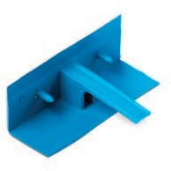

Width / Height: 30 mm Length : 78 mm

#### AD-F-PCAB-30

Width / Height: 40 mm Length : 78 mm

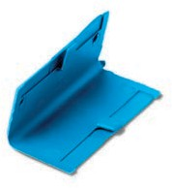

### GALVANIZED CORNER

#### AD-F-GIC-20

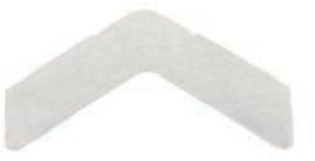

Size : 20 mm

Length : 80 mm

#### AD-F-GIC-30

Size : 30 mm

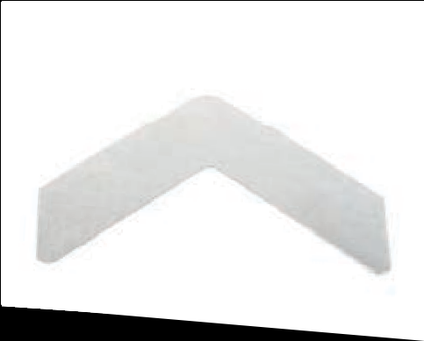

Length : 100 mm

### ALUMINIUM REINFORCEMENT BAR

#### AD-F-ARB

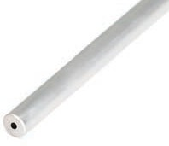

Diameter : 14 mm

Length : 4 m

### POLYMER CROSS FIXING CONNECTOR

#### AD-F-PCFC

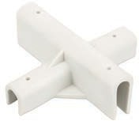

Length : 118 mm

Width : 118 mm

### ALUMINIUM DISC

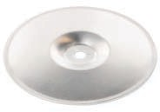

#### AD-F-AD

Diameter : 96 mm

### SELF TAPPING SCREW

#### AD-F-STS

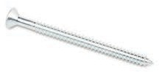

Diameter : 5.5 mm

Length : 75 mm

### ALPHA DUCTS SPECIAL FOAM GLUE

#### AD-F-AG-14

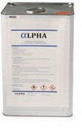

Weight : 14 kg

#### AD-F-AG-12

Weight : 12 kg

#### AD-F-AG-10

Weight : 10 kg

### ALPHA DUCTS ACRYLIC SEALANT

#### AD-F-ASL-W

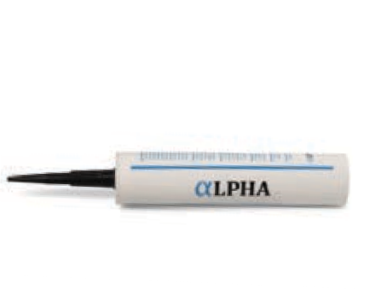

Weight : 400 g

Color : White

#### AD-F-ASL-G

Weight : 400 g

Color : Grey

### ALUMINIUM TAPE

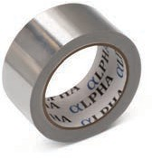

#### AD-F-AT-50-25

Width : 50 mm

Length : 22.86 m

#### AD-F-AT-75-25

Width : 75 mm

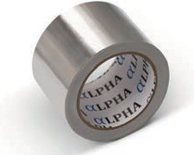

Length : 22.86 m

### ALUMINIUM REINFORCED TAPE

#### AD-F-ART-75

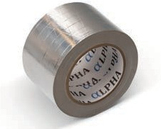

Width : 75 mm

Length : 45.72 m

### ALUMINIUM TIGER CONNECTOR

#### AD-F-ATC

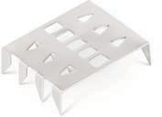

Length : 50 mm

Width : 40 mm

# MANUAL FABRICATION TOOLS

ALPHA DUCTS LLC have specifically developed a complete range of high quality hand tools for manual fabrication of

**ALPHA** pre-insulated air duct systems enabling fast, efficient and economical fabrication operations.

These tools are portable and easy to handle thus removing any restraints related to location and allowing fabrication on site.

### MANUAL FABRICATION TOOL KIT

#### AD-F-TB-10

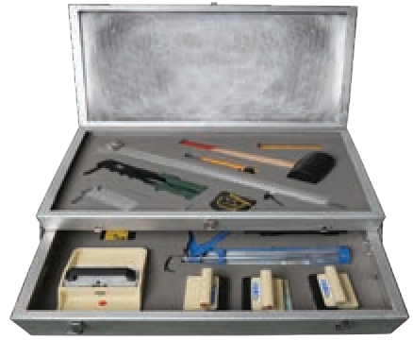

Single blade : Left / 45O cutter

Single blade : Right / 45O cutter

Single blade : Straight / 90O cutter

Double blade : 45O cutter

Manual silicon gun Stiff spatula

Tape marker Rubber hammer Compass

Knife Measuring tape

#### AD-F-TB-5

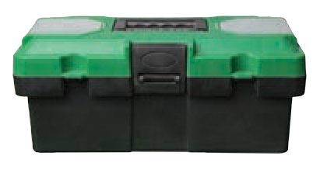

Single blade : Left / 45O cutter

Single blade : Right / 45O cutter

Single blade : Straight / 90O cutter

Double blade : 45O cutter

### SINGLE BLADE CUTTER

#### AD-F-SBC-L

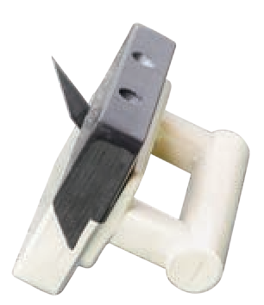

Orientation : Left / 45° Panel : 20 mm and

thickness 30 mm

#### AD-F-SBC-R

Orientation : Right / 45° Panel : 20 mm and

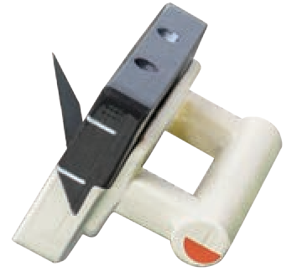

thickness 30 mm

#### AD-F-SBC-S

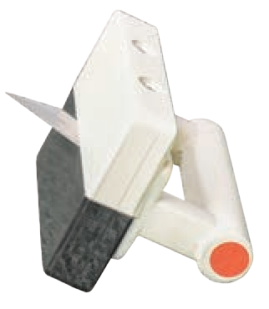

Orientation : Straight / 90° Panel : 20 mm and

thickness 30 mm

### DOUBLE BLADE CUTTER

#### AD-F-DBC-125

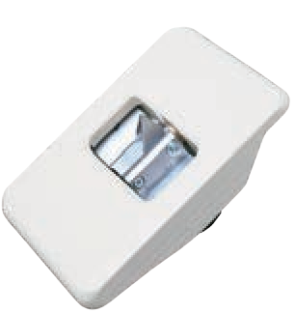

Angle : 12.5°

Panel : 20 mm and

thickness 30 mm

#### AD-F- DBC-225

Angle : 22.5°



Panel : 20 mm and

thickness 30 mm

#### AD-F-DBC-450

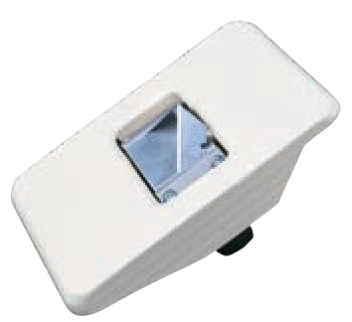

Angle : 45°

Panel : 20 mm and

thickness 30 mm

#### AD-F- DBC-600

Angle : Adjustable

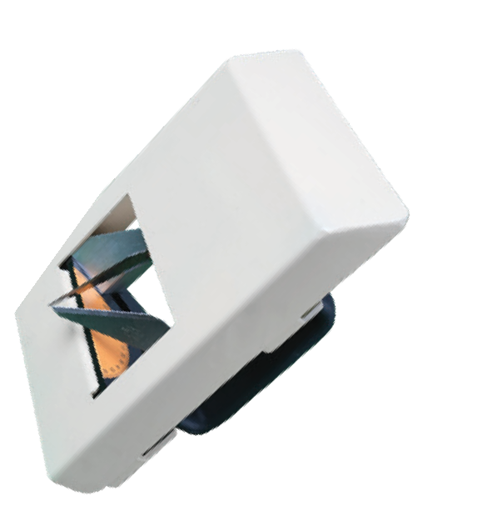

Panel : 20 mm and

thickness 30 mm

### SQUARE IN ALUMINIUM

#### AD-F-SQR-10

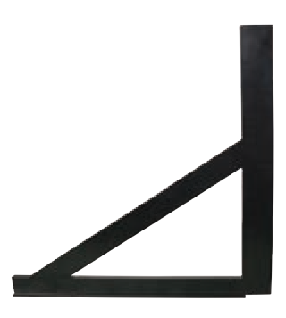

Size : 1200 mm

#### AD-F-SQR-20

Size : 700 mm

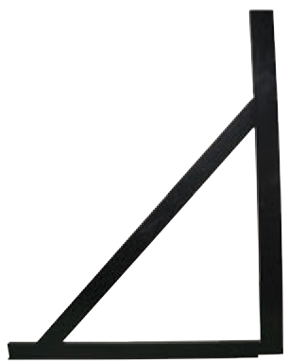

### MANUAL BENDING MACHINE

**AD-F-MBMC**

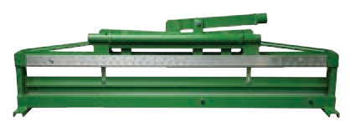

### PNEUMATIC GLUE SPREADER

**AD-F-PGS**

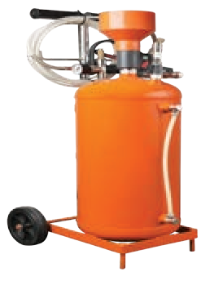

### TAPE MARKER

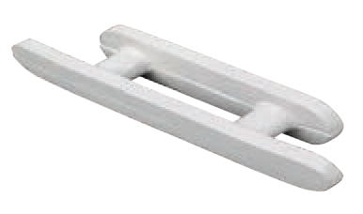

**AD-F-TPMK**

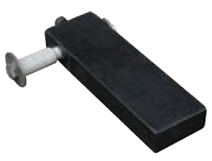

### STIFF SPATULA

**AD-F-SPTL**

### RUBBER HAMMER

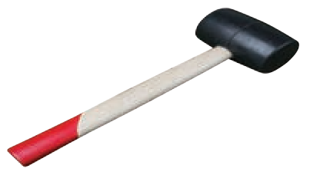

**AD-F-RBHM**

### COMPASS

**AD-F-CPS**

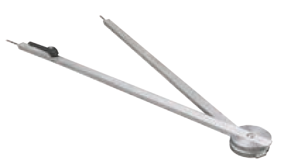

### ALUMINIUM CLAMPING RULER

#### AD-F-CLR-40

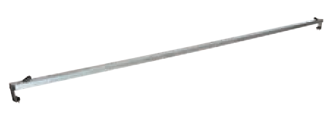

Length : 4 m

#### AD-F-CLR-12

Length : 1.2 m

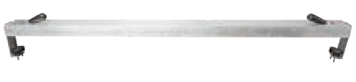

### PORTABLE FABRICATION TABLE

#### AD-F-PTL-40

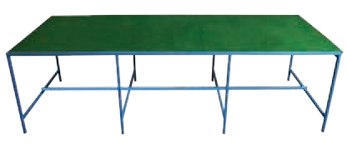

Length : 4 m x 1.2 m

# ICONIC PROJECTS

**ALPHA** pre-insulated air duct systems were used in a variety of prestigious projects covering many building categories like shopping malls, mixed use high rise towers, hotels, community villas and buildings, airport terminals in addition to many more.

## THE RESIDENCES DOWNTOWN DUBAI

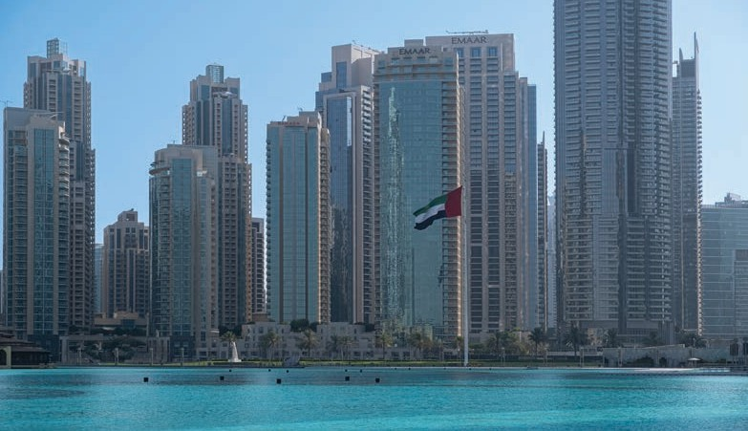

**CONSULTANT** : HYDER CONSULTING / ARIF AND BINTOAK

**PRODUCT** : ALPHA-PIR

: EMAAR

**CLIENT**

**IBN BATTUTA MALL**



**CLIENT** : NAKHEEL **CONSULTANT** : DEWAN AL EMARA **PRODUCT** : ALPHA-PIR

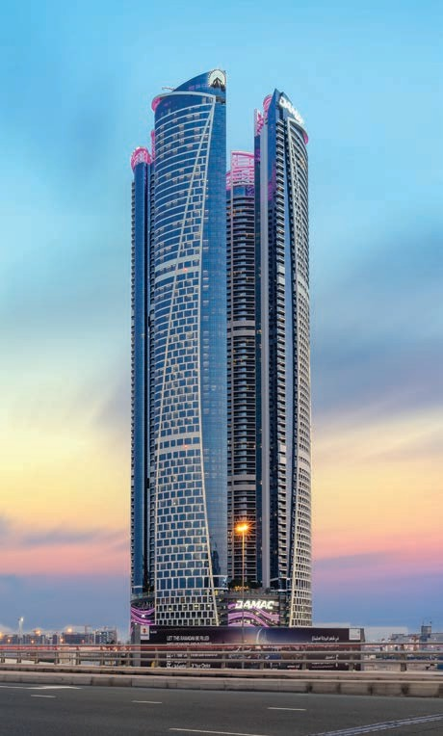

**DAMAC TOWERS**

**BY PARAMOUNT**

**CLIENT**

: DAMAC PROPERTIES

**CONSULTANT** : KEO / KHATIB AND ALAMI

**PRODUCT** : ALPHA-PIR

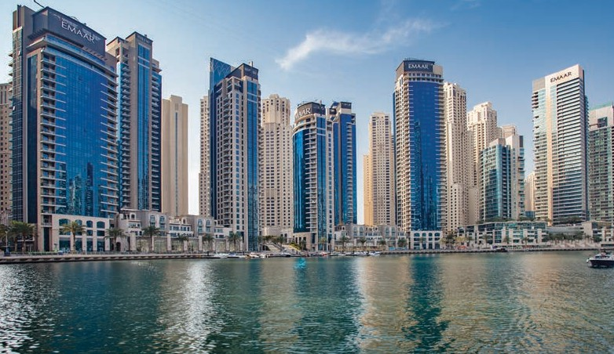

**MARINA PROMENADE**

**CONSULTANT** : HYDER CONSULTING

**PRODUCT** : ALPHA-PIR

: EMAAR

**CLIENT**

**THE RITZ-CARLTON,**



**CONSULTANT** : HYDER CONSULTING

**PRODUCT** : ALPHA-PIR

: UNION PROPERTIES

**CLIENT**

**Dubai International Financial Centre**

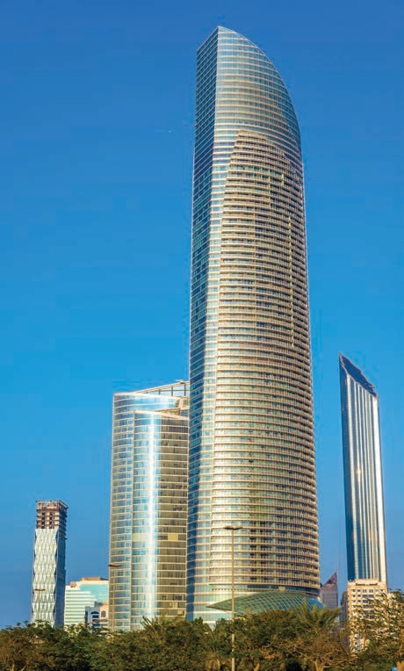

**THE LANDMARK TOWER ABU DHABI**

**CLIENT**

: DEPARTMENT OF PRESIDENTIAL AFFAIRS

**CONSULTANT** : BURO HAPPOLD

**PRODUCT** : ALPHA-PIR

ALPHA DUCTS LLC reserves the right to amend the product specifications without prior notice. Product thickness mentioned should not be considered as available in ex-stock. Final approval must always be obtained from the local Engineer / Authorities prior to the commencement of fabrication and installation.

ALPHA DUCTS LLC believes that the information and recommendations in this catalogue are accurate and reliable. However, since the installation and the usage conditions are not under the control of ALPHA DUCTS LLC, the final performance of the system is the responsibility of the customer.



**ALPHA DUCTS LLC**

P.O. Box 336769 Dubai, United Arab Emirates

Phone : +971 4 2724715

Fax : +971 4 2724904

Mail : [info@alphaducts.com](mailto:info@alphaducts.com) Website : [www.alphaducts.com](http://www.alphaducts.com/)



**MEP for a Better Living**